Project Title: Swarm Mate Audit Workpaper Adapter
Problem:
Audit and tax teams at mid-sized accounting firms often receive client workpapers in fragmented formats such as PDFs, spreadsheets, scanned documents, notes, and support files. Before those materials can be used in legacy systems such as CCH, staff have to manually review them, identify risk areas, track open requests, and draft planning artifacts. Generic AI chat tools can help with isolated drafting tasks, but they often produce ungrounded output that requires cleanup and creates additional review burden.

Audience:
The primary target users are audit teams at accounting firms using legacy systems and document-heavy workflows. These teams are a strong fit because they already work across many scattered files, need structured outputs, and have low tolerance for hallucinations. A secondary audience is tax teams handling client documentation and follow-up requests before data is finalized in downstream systems.

Why does this matter?
This workflow creates unnecessary cognitive load and repeated manual effort. Team members have to read multiple source files, cross-check open items, identify control concerns, and then turn that work into a planning memo, checklist, or client communication. That process is slow, inconsistent, and difficult to scale across staff with different levels of experience.

Success criteria
This project is successful if the system can:
1. ingest a small folder of workpaper-like documents,
2. answer a user request grounded in those documents,
3. generate a structured audit artifact with citations,
4. pass a lightweight quality review step, and
5. save the final output as a reusable report.

User discovery and problem validation
This project was not framed only from a technical interest in MCP or agent swarms. It was refined through a real conversation with Steven Weging, IT Director at CDH, a small accounting firm operating in the tax and audit space. That conversation was important because it exposed the difference between a generic AI coworker idea and the practical needs of a small firm trying to use AI in real workflows.
Steven highlighted that AI use at his firm was already delivering some value, but it was also beginning to create a new cost: low-quality AI output (“AI slop”) that coworkers then had to clean up, reinterpret, or reject. This was especially risky in professional workflows such as tax research, audit research, planning, client letter drafting, General Ledger formatting, and importing bank statements into GL workflows. In other words, the challenge was no longer simply “how do we give people AI access?” It had become “how do we make AI outputs structured, reviewable, and trustworthy enough for business use?”
The conversation also revealed why a one-size-fits-all product like a broad Claude Cowork-style assistant is not the ideal first solution for a firm like CDH. Steven explained that small accounting firms are deeply dependent on legacy vendor ecosystems such as Wolters Kluwer CCH and Thomson Reuters. These systems dominate the market, innovate slowly, and make API access expensive and opaque. In CDH’s case, API access was described as costly enough to be hard to justify, with limited integration value even when paid for. That means the most valuable AI opportunity for a firm like CDH is not deep platform integration first, but rather helping staff with the messy work that happens before data is finalized in those systems.

That user research changed the direction of the project. The original idea was closer to a “Claude Cowork lite” concept: a general MCP-powered coworker that could connect to many sources and help with broad knowledge work. After the Steven Weging conversation, the project became much more specific: a custom workflow adapter designed for document-heavy pre-CCH work. Instead of positioning the solution as a generic assistant that can do a little bit of everything, the system is now framed as a focused tool that can take scattered workpapers, identify risk areas, surface missing requests, draft planning artifacts, and keep citations attached throughout the process.
This is why a custom tool is a better fit for CDH than a generic coworker interface. A custom tool can:
- align to CDH’s actual workflows rather than asking staff to invent their own prompting patterns,
- enforce structured outputs such as planning memos, checklists, and client letters,
- reduce AI slop by grounding outputs in source documents and surfacing citations,
- operate before CCH rather than depending on expensive or limited vendor APIs,
- support a smaller-firm rollout strategy where trust, reviewability, and simplicity matter more than broad platform reach.
In that sense, Steven Weging’s feedback served as the practical research layer that turned this project from a technology demo into a more realistic product pilot. The pain points of a small firm like CDH are not just technical; they are operational, economic, and cultural. They need a tool that fits their current workflow, respects their system constraints, and improves output quality without requiring a full transformation of how the firm already works.

2. Solution
Proposed system
Swarm Mate is a workflow adapter, not a generic coworker. It sits before the legacy accounting system and helps users transform raw client workpapers into structured, review-ready outputs. The current prototype focuses on one high-value workflow: generating an audit planning memo from uploaded or indexed source documents.

Core idea
The system uses an agentic RAG workflow with distinct steps:
- Plan the task and determine what kind of artifact is being requested.
- Retrieve evidence from the available source documents.
- Draft the requested artifact in structured markdown.
- Review the artifact with a lightweight quality gate.
- Finalize and save the report as a reusable output.

UX flow

The intended user flow is:
1. Upload or attach workpapers.
2. Choose a workflow such as audit planning memo, workpaper summary, issues checklist, client letter, or cited Q&A.
3. Enter a task request in natural language.
4. Let the system plan, retrieve evidence, and draft the artifact.
5. Review the generated output, citations, and saved report.

Why is this better than generic AI chat?
Instead of allowing free-form output, the system enforces a controlled workflow with source-grounded evidence, repeatable artifact structures, and a review step. This directly addresses the business concern that “AI slop” costs time and reduces trust.

3. Data + Keys
Data sources
For the prototype, the system uses local sample workpaper-like files stored in a project data folder. These include:
- client overview notes,
- control notes,
- PBC / open request lists, and
- trial balance data.
These files simulate the kinds of pre-CCH documents an audit team would review before finalizing planning materials.
API access / keys
The project uses the OpenAI API for both generation and embeddings. The environment is configured through a local .env file with variables such as:
- OPENAI_API_KEY
- OPENAI_MODEL
- OPENAI_EMBED_MODEL
- PLANNER_MODEL
- QUALITY_MODEL
- retrieval configuration values

Working status
The API layer is working locally. The workflow successfully:
- loads source documents,
- retrieves evidence,
- generates a draft memo
- performs a quality check, and
- saves the final report.

4. Prototype
LangGraph Workflow:

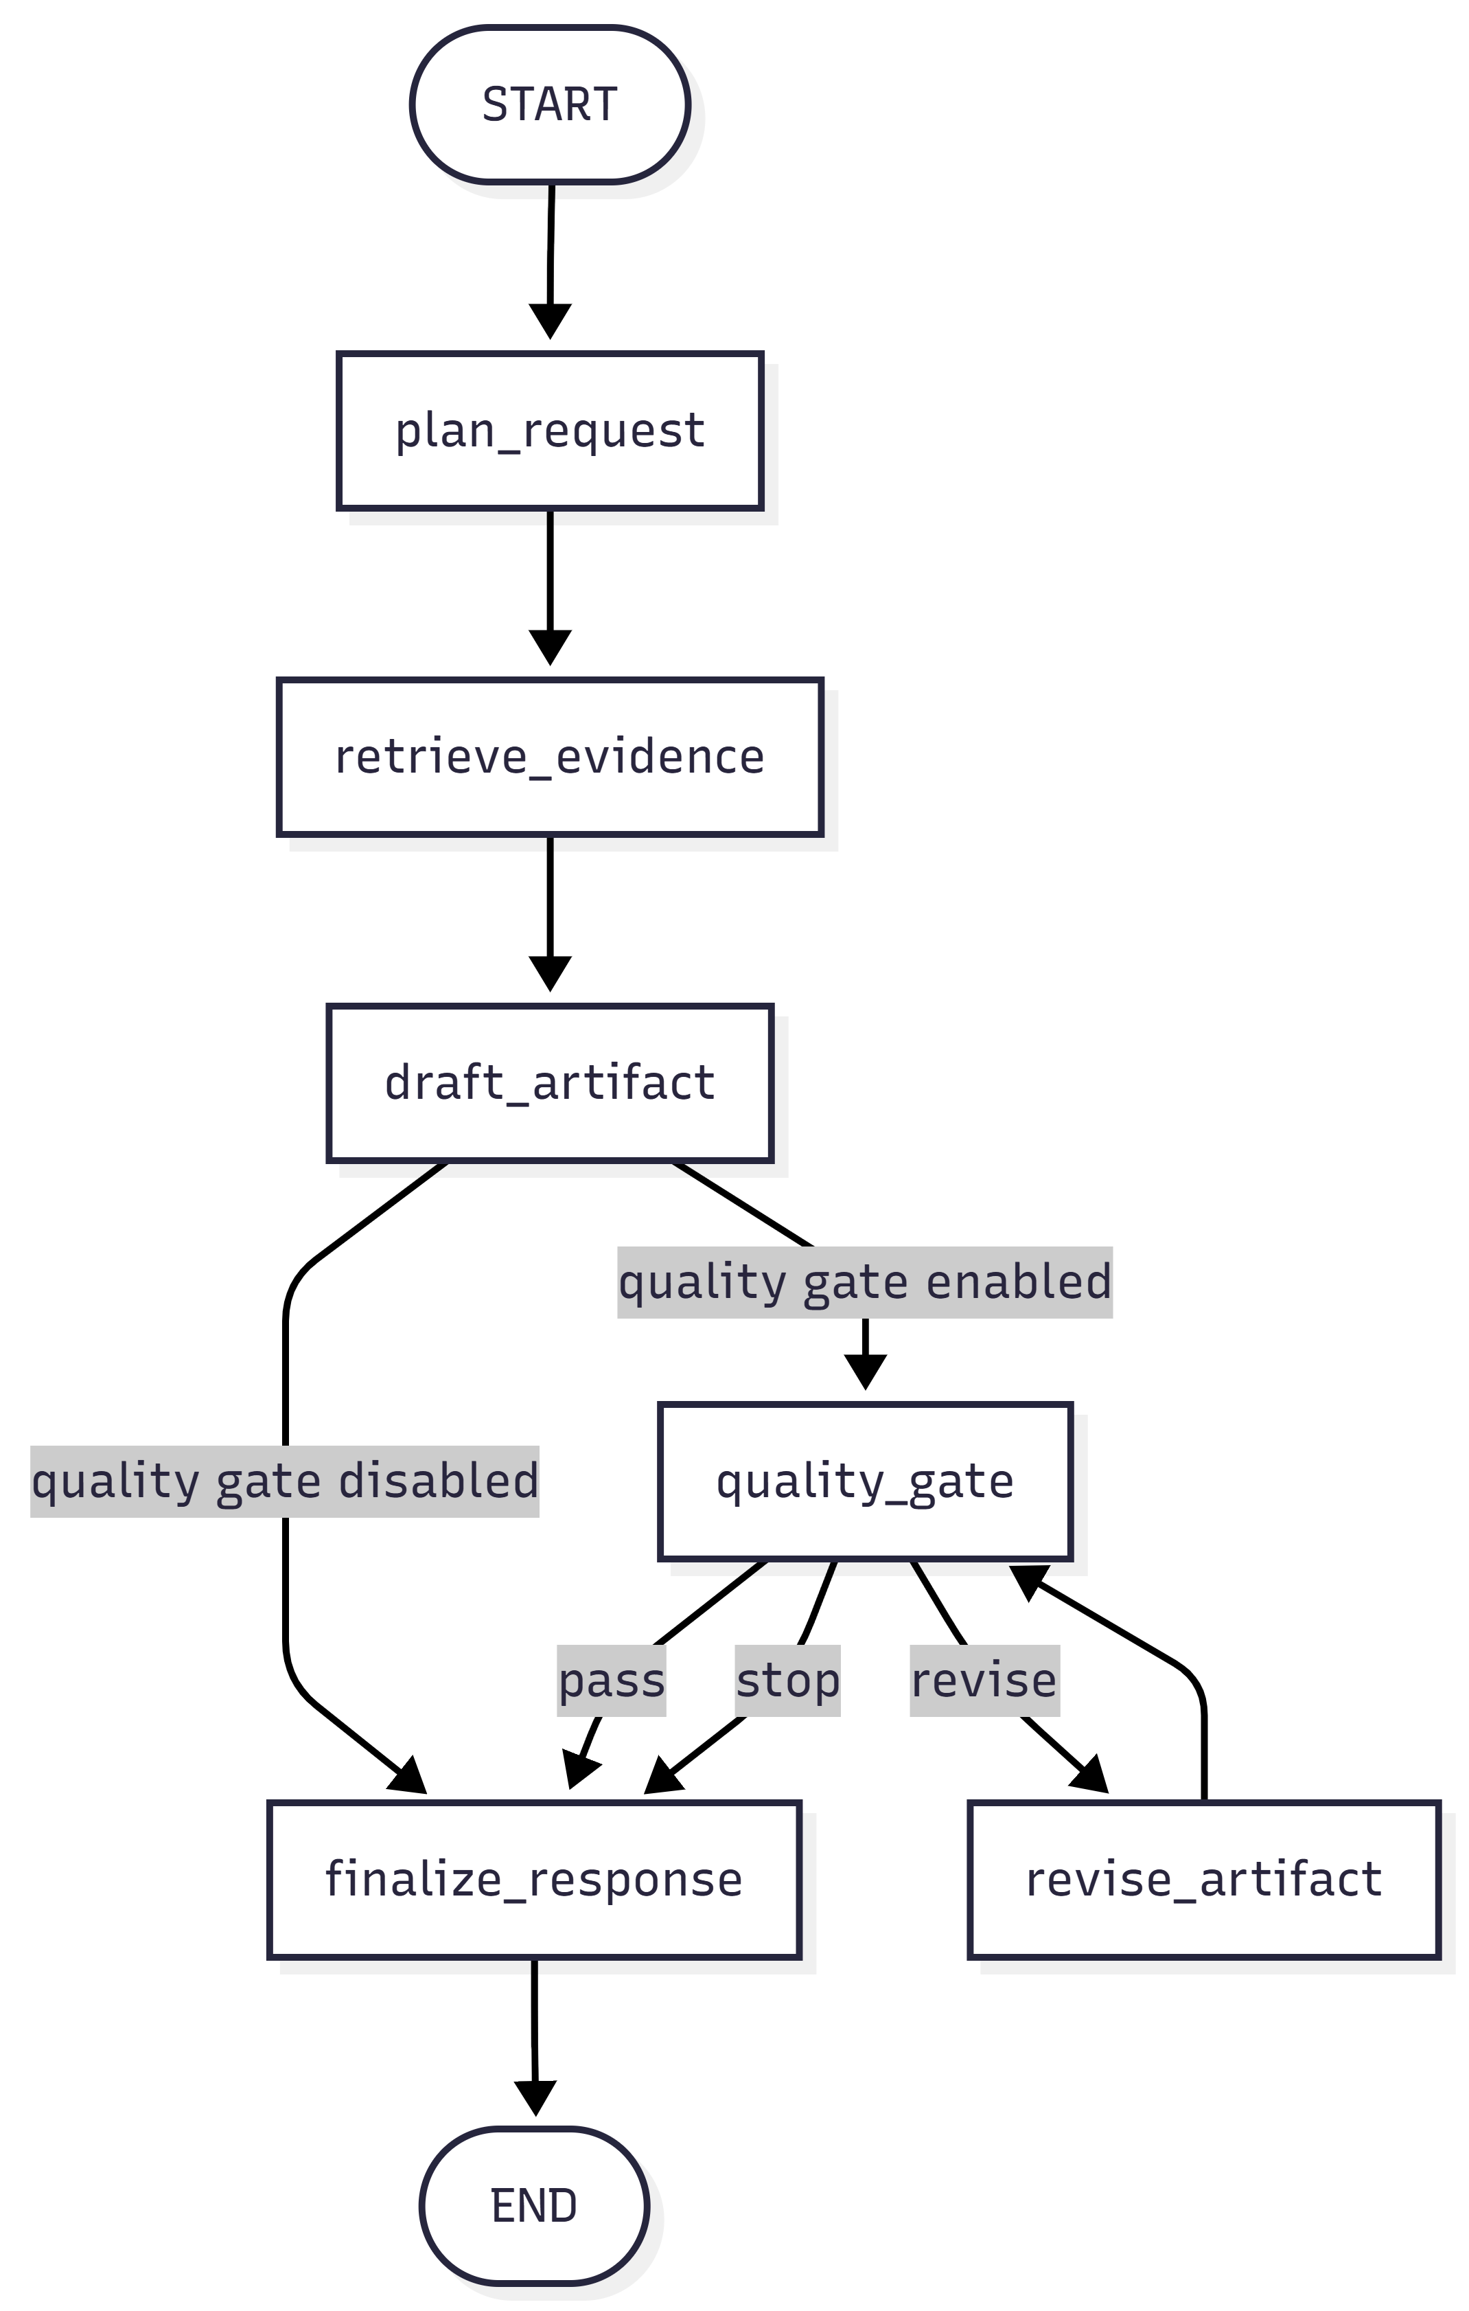

What is implemented
The current prototype is an end-to-end agentic RAG workflow built around a LangGraph-style graph and a thin Gradio UI layer. It supports:
- task planning,
- retrieval over local workpaper-like files,
- grounded drafting,
- quality gate review, and
- report generation.

Example completed workflow
For the prompt:
> “Draft an audit planning memo for this client. Highlight likely risk areas, open requests, and include citations to the source files.”

The system successfully:
- classified the task as an audit planning memo,
- retrieved relevant excerpts from the source files,
- drafted a structured memo,
- cited supporting sources,
- passed the quality gate, and
- saved the final report to disk.

Why these matters?
This demonstrates that the system is not just answering questions; it is producing a real business artifact from messy source material. That is the core value of the workflow adapter approach.

5. Eval Baseline
Goal
The evaluation baseline should measure whether the system retrieves the right evidence and produces usable, grounded outputs.
Synthetic evaluation set
A synthetic evaluation set will be created using representative audit-style questions and tasks, such as:
- What open items are still outstanding from the client?
- What control issues should be highlighted in the planning memo?
- Which risk areas are supported by the trial balance and control notes?
- Draft a planning memo using only the provided sources.

Baseline approach
The baseline system will use the current retrieval setup with the initial chunking, embedding, and top-k configuration. Evaluation will focus on:
- citation relevance,
- answer completeness,
- groundedness to source documents, and
- artifact usefulness for audit planning.

Baseline score
To be filled in after running the evaluation notebook / test set.
Recommended baseline metrics to report:
- retrieval hit rate or context relevance,
- answer faithfulness / groundedness,
- artifact completeness score,
- qualitative reviewer assessment.

6. Retriever Upgrade
Planned retriever improvement
After establishing the baseline, the retriever will be upgraded by improving one or more of the following:
- better chunking strategy,
- revised chunk size / overlap,
- tuned top-k retrieval,
- query rewriting or multiple retrieval queries,
- reranking of retrieved chunks.
What will be compared
- The before/after comparison should measure whether the upgraded retriever:
- improves citation quality,
- reduces irrelevant context,
- increases groundedness,
- produces better final artifacts.

Improved metrics + analysis
To be filled in after running the upgrade experiment.
The analysis section should explain:
- what was changed,
- why it was changed,
- how the metrics shifted,
- whether the extra complexity is worth it.

7. Next Steps
Toward a polished Demo Day version
The next steps for this project are:
1. polish the Gradio UI for a cleaner workflow-driven experience,
2. support file upload as the primary source-attachment flow,
3. make workflow selection explicit and controllable from the UI,
4. add report export options beyond markdown,
5. improve retrieval evaluation and document traceability,
6. expand to additional workflow types such as client letters and issues checklists,
7. later explore connector-style or MCP-backed source integration.

Longer-term vision
The longer-term direction is to evolve SwarmMate into a domain-specific coworker for accounting teams that sits before legacy systems and helps produce grounded, review-ready artifacts. Rather than replacing systems like CCH, it improves the messy human workflow that happens before final data entry and formal review.

Summary
Swarm Mate Audit Workpaper Adapter is a focused pilot for a real business problem: audit teams waste time turning fragmented client workpapers into structured outputs, while generic AI tools often create ungrounded drafts. This project demonstrates that an agentic RAG workflow can act as a reliable workflow adapter by planning tasks, retrieving evidence, generating cited artifacts, and saving reusable reports. The prototype is already functional, and the next milestone is to formalize the evaluation baseline and retriever improvement story for the certification challenge.

